Kalman Observer for target guarding problem**:**

*Assumptions:*

1. Evader (E) moves with constant velocity (no process noise) and he knows the pursuer’s initial position and velocity.
2. He plays optimally and moves toward the interception point (I)**.**
3. The sensor has normally distributed measurement noise.
4. Pursuer (P) also moves with constant velocity.

*Model:*

Let the initial position of E be  and initial velocity be.

Evader’s position and velocity are considered as states.

  

Where and  are velocities in  and  directions.  is step size.

*Output:*

, where, ,  are noises with normal distribution. is the covariance matrix of the noises.

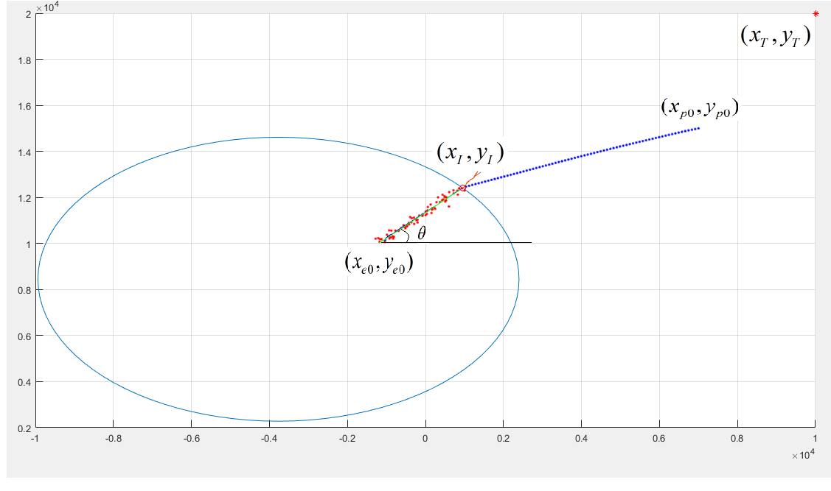

*State space model:*

 , Where   is observable.

*Kalman filter:*

   

Where  is the estimate at time  based on outputs of the system till time.

 is the next state with  as present state.

Input, = 



 is state error covariance matrix  . Note that input error covariance matrix,  is not considered in equation (1). So the Kalman gain calculated, will not be the best gain update and so will be the state estimates.

Let the initial measurement be ().  be initial error covariance matrix. These are considered as initial estimates.

*Update Equations:*

Kalman gain factor, 

, 

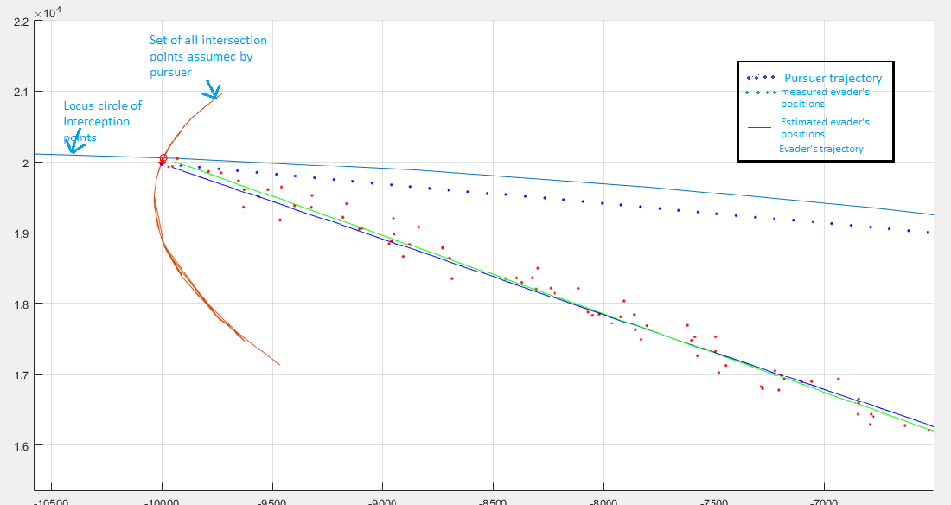

Fig 2. The game

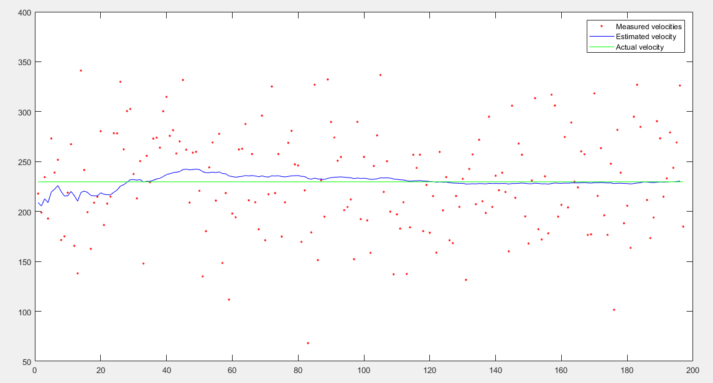

Fig 3. Velocity profile of the evader

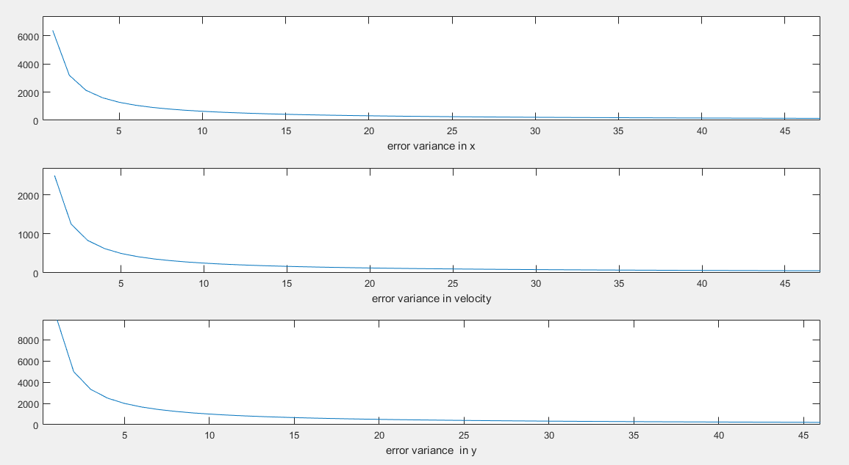

Fig 4. Diagonal elements of P

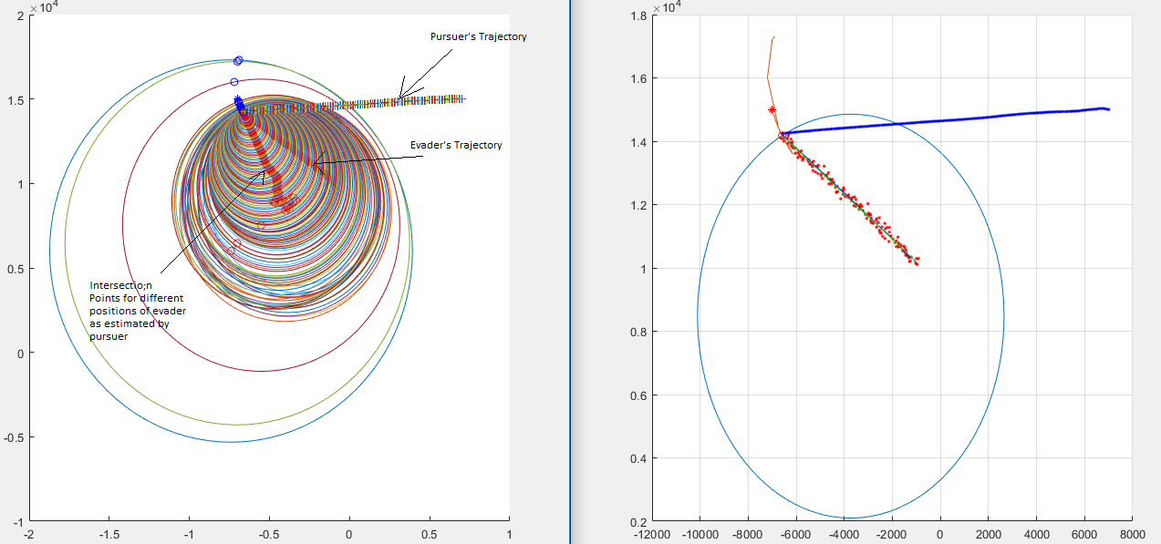

Fig 5 Family of Apollonius circles and corresponding interception points as perceived by pursuer during the game

*Things yet to be done*:

1. Calculate input error covariance matrix and correct the update equations to improve convergence time.
2. Extend the solution to moving target and varying evader’s velocity cases.